Mind map assignment

Submitted as part of the course Sustainable Energy Transition



Uppsala University

Campus Gotland

Tomasz Garbus

05.03.2025

Contents

Mind map assignment 1

References 3

Mind map assignment

Mind map made in MindMup

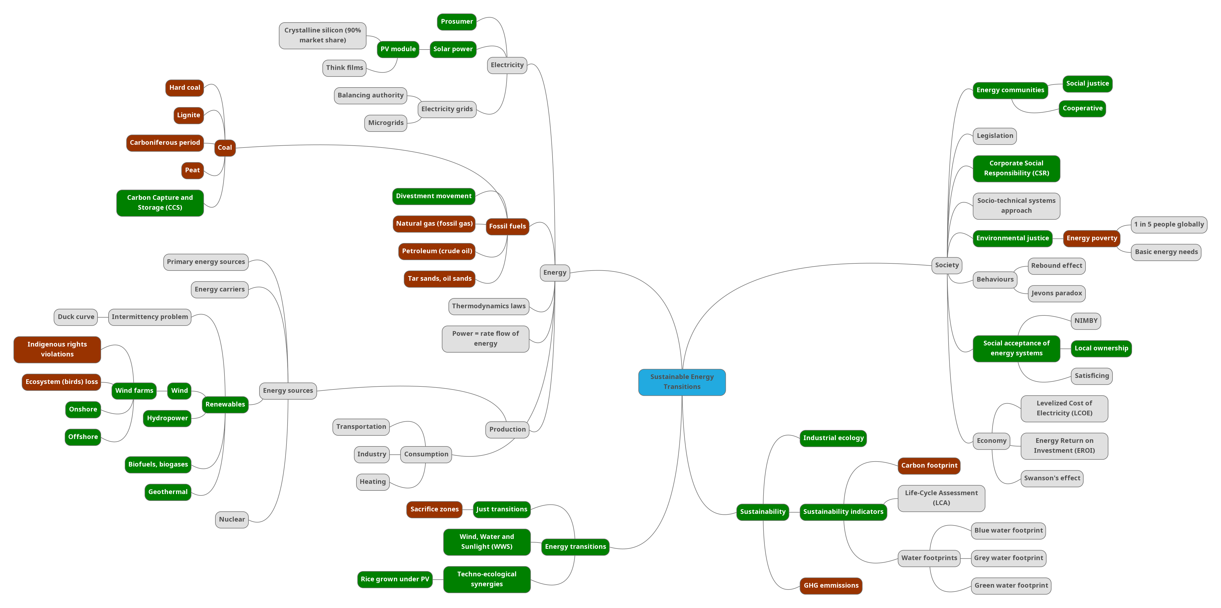

Structure of the proposed mind map

This assignment reminded me of a Climate Fresk workshop I took part in a few years ago. Participants of the workshop are given, in several consecutive rounds, stacks of cards concerning different climate phenomenons, industries, lifestyles etc. and are asked to place them on a large sheet of paper and draw lines representing causal relationships between them. I remember that our group was overwhelmed with the amount of mutual causalities between cards and feedback loops and we really struggled to draw clear lines and keep the graph at least somewhat readable.  
  
Understanding the complexity of connections between all elements of the mind map, I considered using the Python library Igraph (The igraph development team, 2025) to cast this deeply connected graph on a 2D plane. On the other hand, there is value in representing knowledge in hierarchical structure of mind map, so I settled on using MindMup.

I combined two strategies for creating connections in my mind map:

1. Some categorizations seemed obvious, for instance different types of coal (*hard coal*, *lignite*, *peat*) should be children of the parent node *coal*.

2. For other connections, I connected terms that first occurred together in Mulvaney's (2020) book.

Finally, a note on colouring. I considered multiple colouring strategies:

1. Colour entire subtrees of the mind map together. It arguably looks the best, but brings no additional information to the graph.

2. Try to identify groups of connected terms and assign these groups same colors. Given the multitude of connections, any such grouping felt very arbitrary.

3. If some term denotes a technology or phenomenon overwhelmingly positive for energy transitions, colour it green. In the contrary case, colour it red. Leave other terms with the default colour. I settled with this idea.

**Examples of interdisciplinarity**

The first example that comes to my mind has to do with the crucial role of legal expertise on so many fronts of energy transition. The short film by Patagonia (2021) shows the crucial role of the organization REScoop in the development of new pieces of legislation under the Clean Energy Package adopted by EU. Lawyers' support is also crucial for navigating the legal frameworks by energy communities, especially given that these frameworks are often outdated or unfavourable (REScoop, 2024).

Transportation, one of the sectors with lowest renewable energy shares, is another example for huge demand for interdisciplinarity. Urban planners have the responsibility of transforming cities to be more walking- or bike-friendly, as well as making public transportation a more attractive alternative to cars. Economists have to predict how subsidising EVs will change their market share. Range anxiety can be seen as a combination of a primarily engineering problem (of building longer-lasting batteries, faster charging, exchangable batteries) and again a complex interdisciplinary problem of expansion of charging stations to rural areas.

References

Mulvaney, D., 2020. *Sustainable Energy Transitions*. Cham: Palgrave Macmillan Cham.

Patagonia, 2021. We the Power: The Future of Energy is Community-Owned | Patagonia Films. [video online] Available at: <https://www.youtube.com/watch?v=75A9WGxoUn8> [Accessed 23 February 2025].

REScoop, 2024. *May success story: Unleashing the potential of community energy in Poland.* [online] Available at: <https://www.rescoop.eu/news-and-events/stories/may-success-story-unleashing-the-potential-of-community-energy-in-poland> [Accessed 23 February 2025].

The igraph development team, 2025. Igraph. [Python library] The igraph development team. Available at: <https://python.igraph.org/en/latest/tutorial.html>.